Partial Differential Equations (PDE)

Definition

Partial Differential Equations (PDEs) are equations that involve rates of change with respect to continuous variables. They are fundamental in describing various physical phenomena such as heat conduction, wave propagation, fluid dynamics, and many more. A PDE is generally of the form:

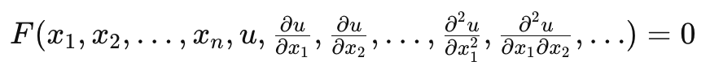
where u = u(x₁​,x₂​,…,x_{n}​) is the unknown function, and the partial derivatives of u with respect to the variables x₁ ​,x₂​,…,x_{n}​ are involved.

Types of PDEs Relevant to Machine Learning
By illustrating how these types of PDEs are applied to familiar machine learning tasks like image processing, dimensionality reduction, and sequence prediction, students can better understand the relevance and application of PDEs in their field.
PDEs are generally classified into three main types:
- Elliptic PDEs: These are often used in machine learning for tasks involving steady-state processes. An example is Poisson's equation:
Δu = f
In machine learning, this can be relevant for image processing tasks such as image inpainting and denoising, where the goal is to reconstruct or restore an image by solving a PDE that models the smoothness of the image.
- Parabolic PDEs: These describe diffusion processes and are used in machine learning for modeling time-dependent phenomena. An example is the diffusion equation:
u_{t} ​= DΔu.
In machine learning, this equation is used in techniques such as diffusion maps, which are methods for nonlinear dimensionality reduction and manifold learning. It helps in understanding the intrinsic geometric structure of high-dimensional data by simulating a diffusion process over the data points.
- Hyperbolic PDEs: These describe dynamic systems and are useful in machine learning for tasks involving temporal evolution and wave-like phenomena. An example is a simplified form of the wave equation used to model certain types of neural networks:
u_{tt}=c²Δu
In machine learning, hyperbolic PDEs can be related to neural networks that need to capture dynamic behaviors, such as recurrent neural networks (RNNs) and transformer models for sequence prediction and natural language processing. These models often need to understand and predict the temporal evolution of data.

Relevancy to Machine Learning
By leveraging the mathematical rigor and the vast array of analytical tools developed for PDEs, machine learning models can be made more robust, interpretable, and capable of handling complex and high-dimensional data. PDEs play a significant role in machine learning, particularly in the following areas:
- Modeling and Simulations: Many real-world phenomena modeled by PDEs can be simulated and predicted using machine learning techniques. For instance, climate modeling, fluid dynamics, and material sciences.
- Neural Networks: Physics-informed neural networks (PINNs) are a class of machine learning models that leverage PDEs to solve inverse problems and data-driven discovery of physical laws. They integrate the physical laws described by PDEs into the training process.
- Optimization Problems: Many optimization problems in machine learning, such as those in deep learning, can be framed as PDEs. For instance, gradient descent can be seen as a discrete approximation of continuous optimization processes described by PDEs.
- Feature Extraction and Dimensionality Reduction: Techniques such as diffusion maps, which are based on the heat equation, are used for nonlinear dimensionality reduction and manifold learning.
- Graph Neural Networks (GNNs): GNNs sometimes use PDE-based frameworks to model spatial dependencies and dynamics on graphs.
- Numerical Methods: Many machine learning methods, particularly those involving large-scale data and complex models, use numerical methods that are derived from solving PDEs.

Elliptic PDE Example: Poisson's Equation

Elliptic PDEs are often encountered in steady-state problems. A common example is Poisson's equation, which is widely used in fields such as image processing, physics, and engineering.

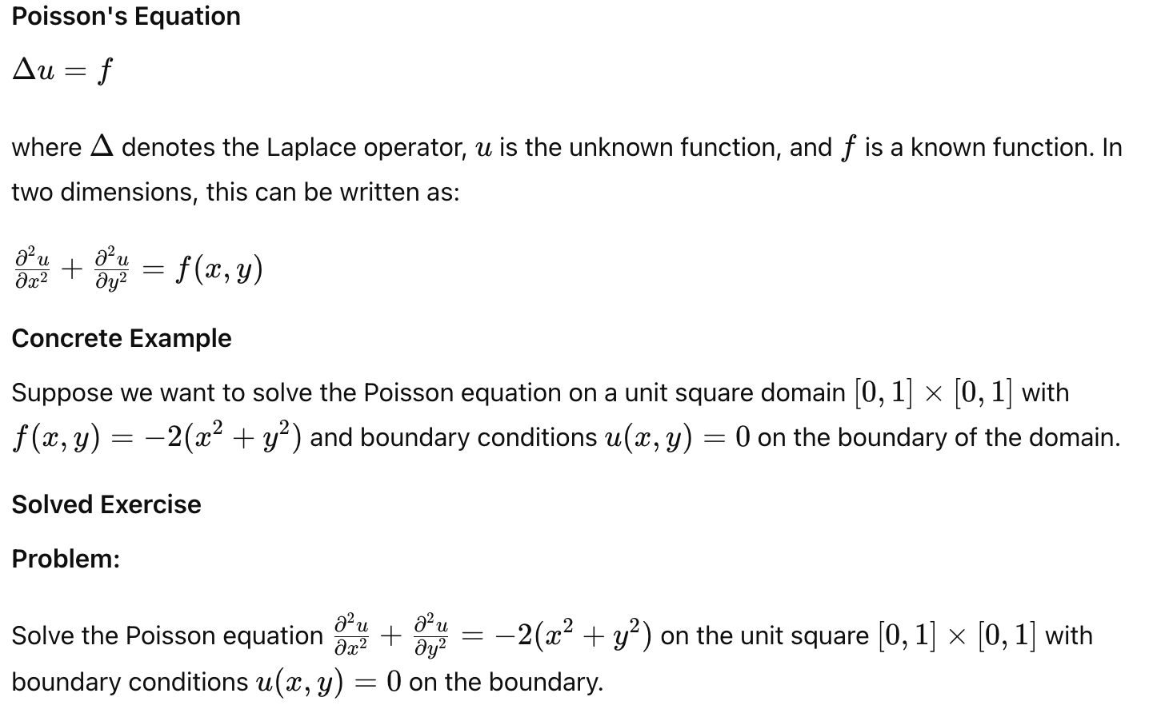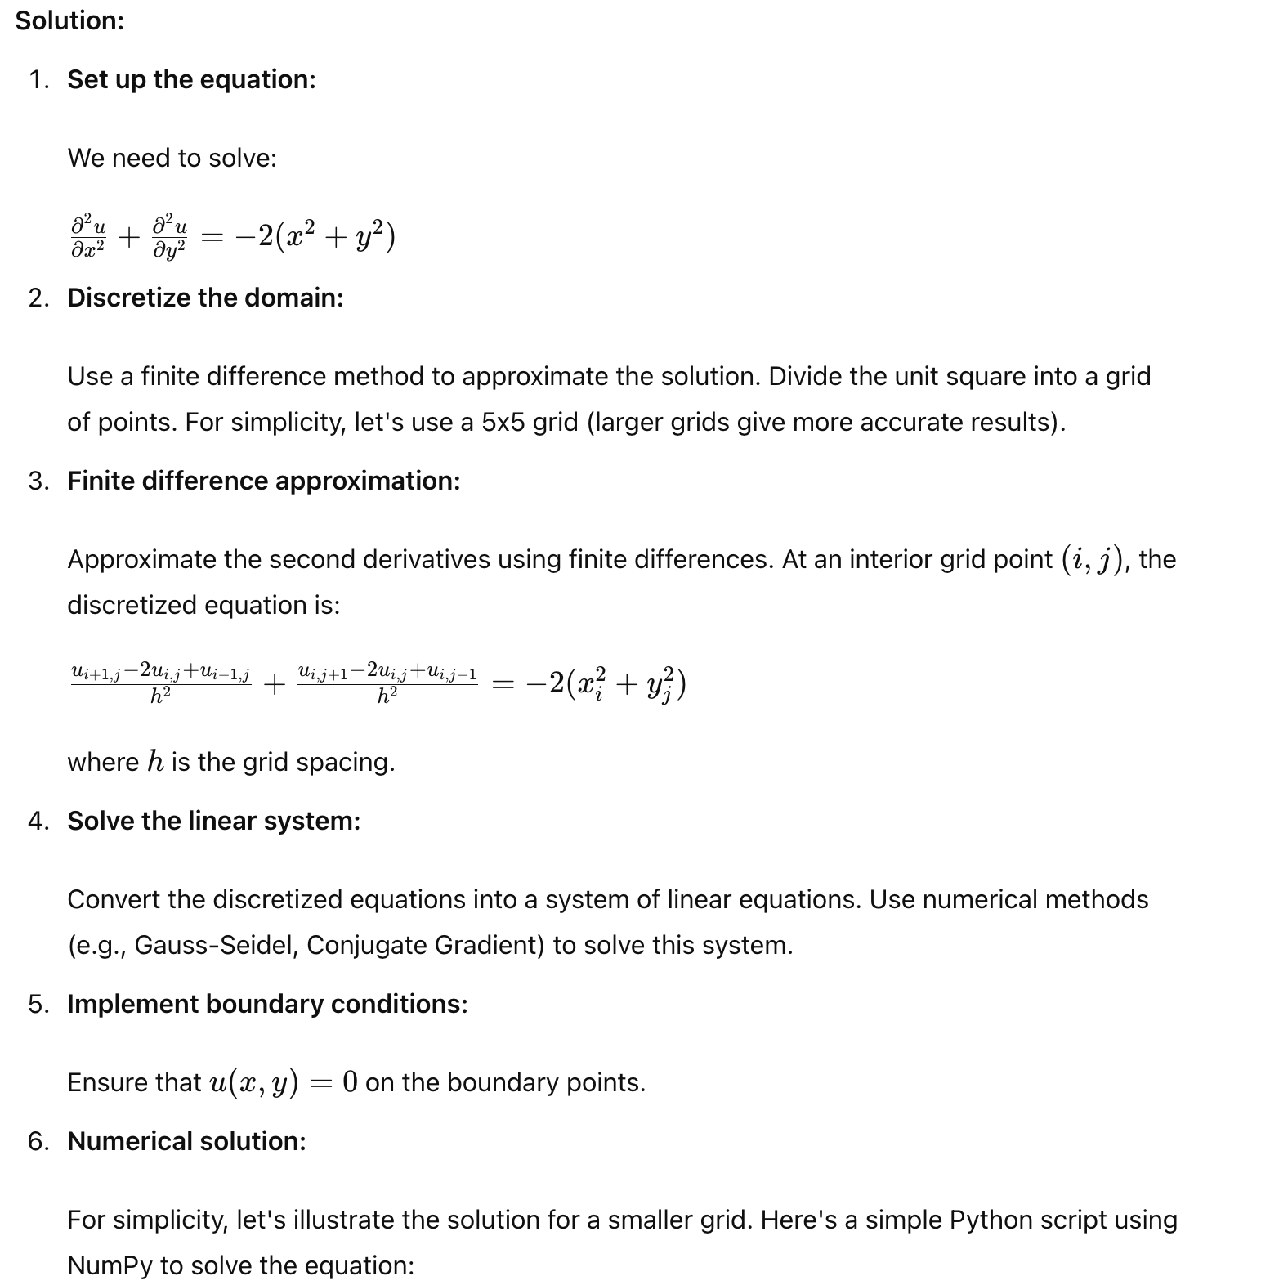

This code sets up a grid, initializes the right-hand side f, applies the boundary conditions, and iteratively solves the linear system using the Gauss-Seidel method. The resulting plot shows the numerical solution to the Poisson equation on the unit square.

import numpy as np
import matplotlib.pyplot as plt

# Grid parameters
N = 5 # Number of interior points
L = 1.0
h = L / (N + 1)
x = np.linspace(0, L, N+2)
y = np.linspace(0, L, N+2)

# Right-hand side
f = np.zeros((N+2, N+2))
for i in range(1, N+1):
for j in range(1, N+1):
f[i, j] = -2 * (x[i]**2 + y[j]**2)

# Initialize u
u = np.zeros((N+2, N+2))

# Iterative solver (Gauss-Seidel)
max_iter = 1000
tol = 1e-5
for _ in range(max_iter):
u_old = u.copy()
for i in range(1, N+1):
for j in range(1, N+1):
u[i, j] = 0.25 * (u[i+1, j] + u[i-1, j] + u[i, j+1] + u[i, j-1] - h**2 * f[i, j])
if np.linalg.norm(u - u_old) < tol:
break

# Plot the solution
X, Y = np.meshgrid(x, y)
plt.contourf(X, Y, u, cmap='viridis')
plt.colorbar()
plt.title('Solution of Poisson\'s Equation')
plt.xlabel('x')
plt.ylabel('y')
plt.show()

Parabolic PDE Example: Diffusion Equation
Parabolic PDEs are often used to describe processes that evolve over time. A common example is the diffusion equation, which models the distribution of a quantity (e.g., heat, concentration of a substance) over space and time.
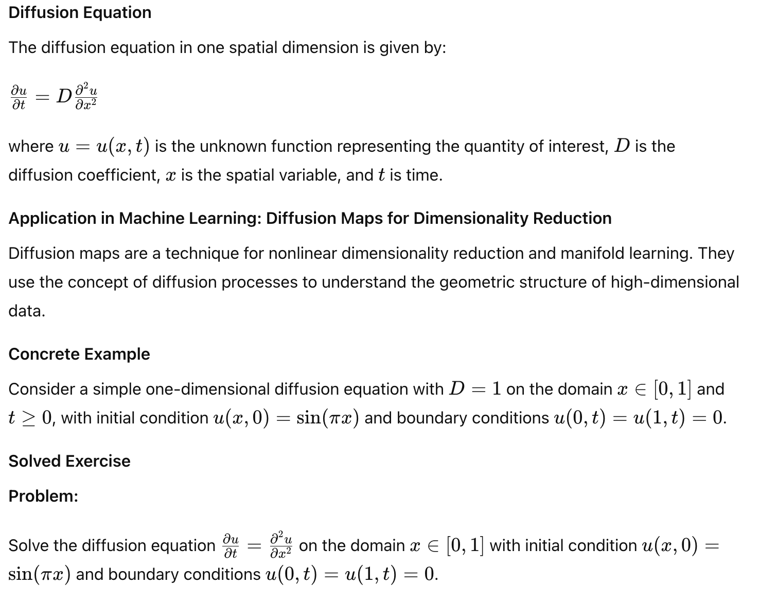
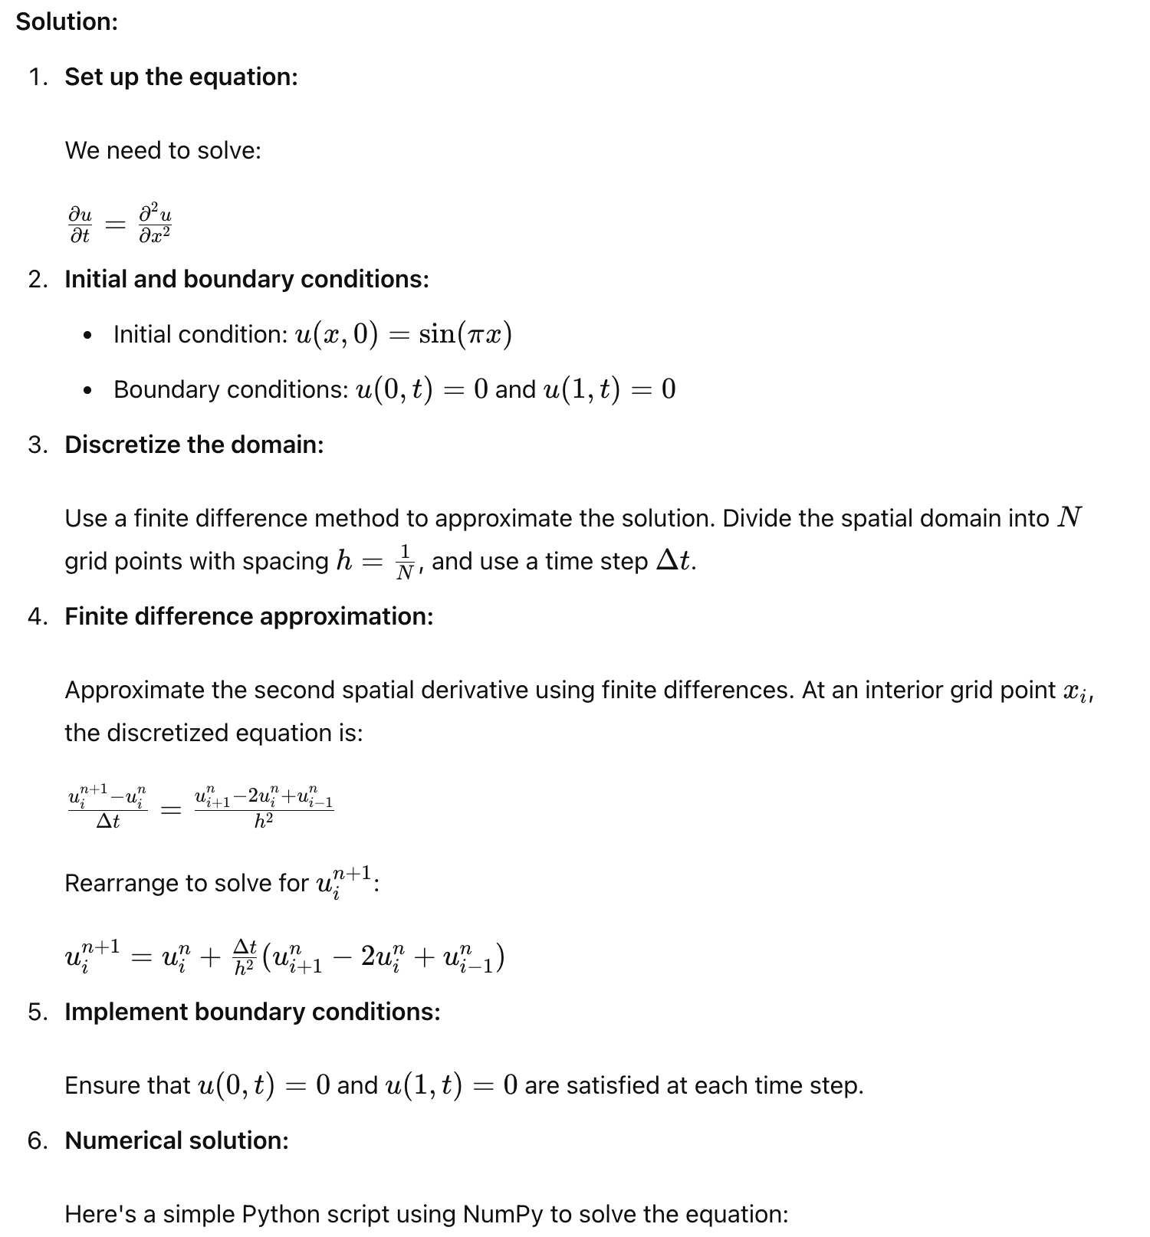

This code sets up a grid, initializes the solution with the given initial condition, applies the boundary conditions, and iteratively solves the linear system using an explicit time-stepping scheme. The resulting plot shows the numerical solution to the diffusion equation at the final time T.

import numpy as np
import matplotlib.pyplot as plt

# Parameters
N = 10 # Number of spatial grid points
L = 1.0 # Length of the domain
T = 0.1 # Total time
D = 1.0 # Diffusion coefficient
h = L / N # Spatial step size
dt = 0.0001 # Time step size
alpha = dt / h**2

# Discretized spatial domain
x = np.linspace(0, L, N+1)

# Initial condition
u = np.sin(np.pi * x)

# Time-stepping loop
num_steps = int(T / dt)
for _ in range(num_steps):
u_new = u.copy()
for i in range(1, N):
u_new[i] = u[i] + alpha * (u[i+1] - 2*u[i] + u[i-1])
u = u_new

# Plot the solution
plt.plot(x, u, label='Numerical solution')
plt.xlabel('x')
plt.ylabel('u(x, T)')
plt.title('Solution of the Diffusion Equation')
plt.legend()
plt.show()

Hyperbolic PDE Example: Modeling Sentiment Dynamics in Text Data
Hyperbolic PDEs can be used to model the dynamics of sentiment in text data over time, which is relevant for applications in natural language processing (NLP) and sentiment analysis.

Wave Equation Adapted for Sentiment Dynamics
The wave equation can be adapted to model the propagation of sentiment over time in a sequence of text data. The idea is to treat sentiment as a "wave" that evolves over the sequence.
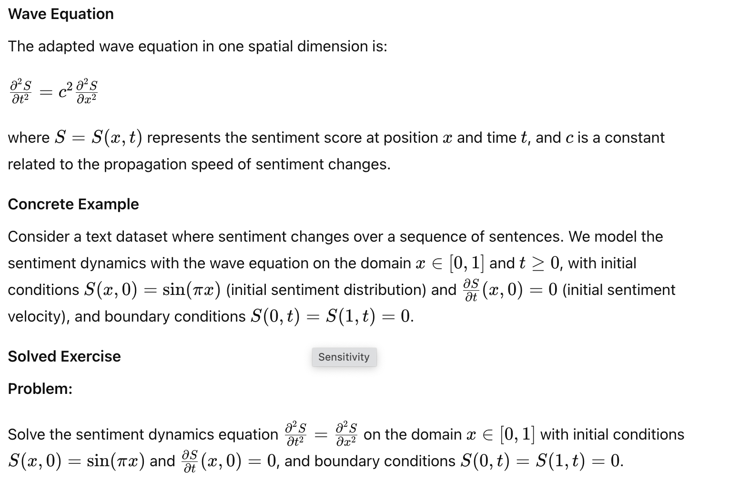
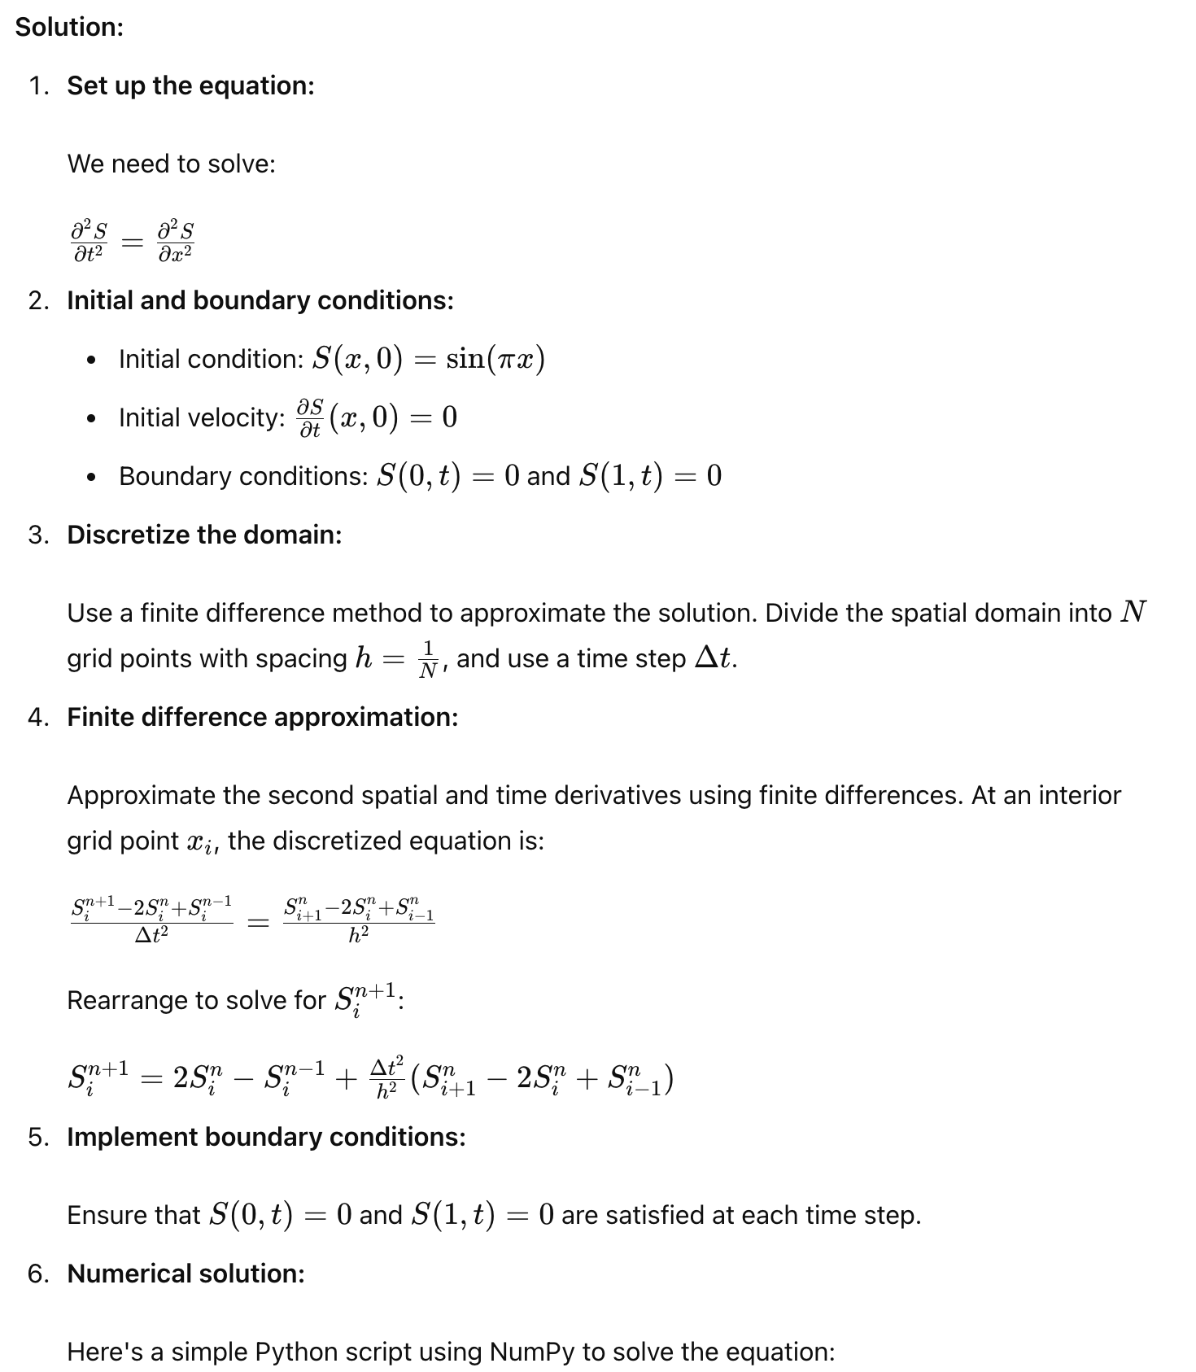
This code sets up a grid, initializes the sentiment distribution with the given initial condition, applies the boundary conditions, and iteratively solves the linear system using an explicit time-stepping scheme. The resulting plot shows the numerical solution to the sentiment dynamics equation at the final time TTT.

Application in Machine Learning
The wave equation can be used to model sentiment dynamics in text data. By understanding how sentiment propagates through a sequence of text (e.g., a series of sentences or a document), machine learning algorithms can be better trained to predict sentiment trends and changes over time. This approach can enhance tasks such as sentiment analysis, opinion mining, and emotion recognition in NLP.
import numpy as np
import matplotlib.pyplot as plt

# Parameters
N = 50 # Number of spatial grid points
L = 1.0 # Length of the domain
T = 1.0 # Total time
c = 1.0 # Wave speed
h = L / N # Spatial step size
dt = 0.005 # Time step size
r = c * dt / h # Courant number

# Discretized spatial domain
x = np.linspace(0, L, N+1)

# Initial condition
S = np.sin(np.pi * x)
S_new = np.zeros_like(S)
S_old = np.sin(np.pi * x)

# Time-stepping loop
num_steps = int(T / dt)
for _ in range(num_steps):
for i in range(1, N):
S_new[i] = 2*S[i] - S_old[i] + r**2 * (S[i+1] - 2*S[i] + S[i-1])
S_old = S.copy()
S = S_new.copy()

# Plot the solution
plt.plot(x, S, label='Numerical solution')
plt.xlabel('x')
plt.ylabel('S(x, T)')
plt.title('Solution of the Sentiment Dynamics Equation')
plt.legend()
plt.show()

